8.00-9.00 | Focussed activity following the teacher video and completing the daily tasks.  This will be either English or Maths on your class Dojo.  https://www.classdojo.com/
9.00-9.30 | Structured play activity – see today’s Homework Site to find out what the suggested activity could be.  https://fs2homework.weebly.com/
9.30-10.00  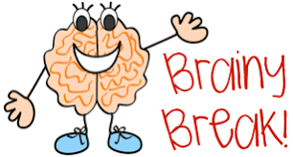 | Snack time- make sure you have plenty of water to keep your brain working.  Jamie’s Brain Breaks: https://www.youtube.com/results?search_query=jamies+brain+breaks
10.00-11.00 | Arabic Lessons
11.00-11.30  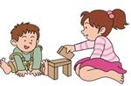 | Structured play activity – Remember to upload your work to your Portfolio so your teacher can see your activities and let you know what they think.
11.30-12-00 | Storytime/ Rhyme time- Listen to your teacher read a story or sing some rhymes. Talk to your adult about the story, practise your rhymes and songs  https://drive.google.com/file/d/1wb7MM5Ud7LXyjmf2wnYjIQjd58gaM_Ix/view?usp=sharing  Bug Club  https://www.activelearnprimary.co.uk/login?c=0
12.00-12.30 | Body Coach Live PE Videos  https://www.youtube.com/user/thebodycoach1/videos  Wake Up Shake Up https://www.youtube.com/watch?v=1gUbdNbu6ak  Go for a safe walk.
12.30-1.30 | Lay the table and eat together, share a meal and talk about something new you learned today.  Be kind and say something you like about each other.
1.30-2.00 | Independent Learning- what independent tasks did your teacher set today?  Education City: https://www.educationcity.com

