Distance Learning - Week Beginning 22nd March 2020

Day | English Activity | Math
Sunday Activity: Making Saltdough

Sun  22nd | Saltdough Caterpillar  At school we have been reading ‘The Very Hungry Caterpillar’. He eats and grows but makes some healthy and unhealthy choices. Today we will make a saltdough model. Here is a link to an easy recipe.  https://www.youtube.com/watch?v=L7sH9bj-fl0  Make sure you include:  - What you used?  - How you made it?  - A prediction of what will happen when we leave it outside.  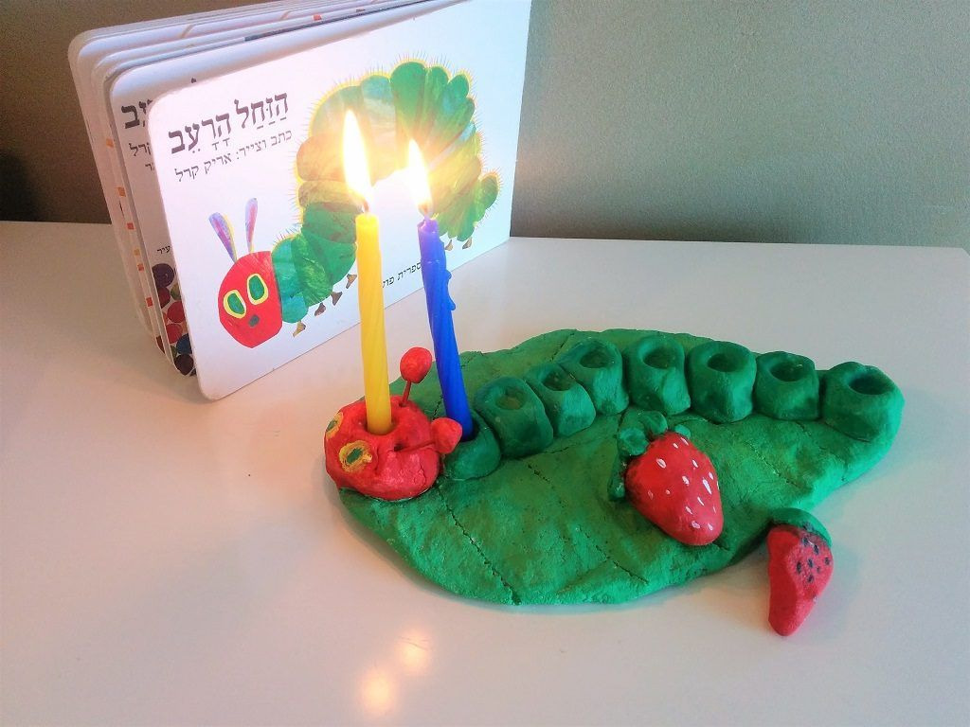  Remember to take a photo or video of your work and send it to me.  Link to book being read online:  https://www.youtube.com/watch?v=75NQK-Sm1YY | Counting to match a given number  Reciting numbers to 5/10 and counting  Today we will say the number next to our caterpillar and then count to that number aloud. We can clap, stomp, jump to match that number. Reinforce counting clearly and in order.  The children will then print the correct number of spots on their caterpillar using finger paint, colour pencils or prints.  - Send me a picture of you carrying out this task on Dojo!  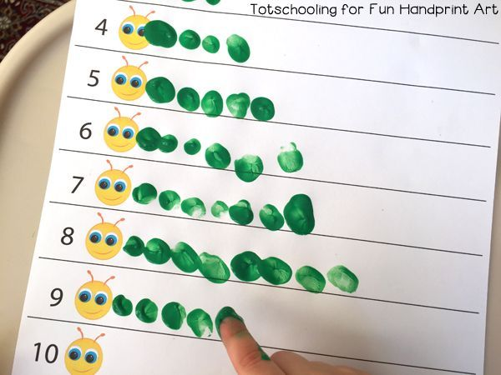  - Can you let it dry and then count the spots you made, touching each one as you say the numbers aloud?  Don’t forget to check Education City and complete the set classwork for this week.
Monday Activity: Making a smoothie

Mon  23rd | Making a Smoothie  Today we will make a smoothie in our house. What do you want to add to your smoothie?  - What will you add?  - What colour is your smoothie?  - How does it taste, sweet/sour/bitter/delicious?  Remember to take a photo or video of your work and send it to me.  Additionally, can you write the first letter of your name and send me a picture? Can you write some more? | Feeding the hungry monkey  Can you cut up the bananas and ffed them to the monkeys. Do they have the same or different? Who has more and who has less?  - How many bananas does the monkey have?  - Who has more?  - How do you know?  Send some pictures of what you have discovered! As a challenge how can we share the bananas, so it is fair?  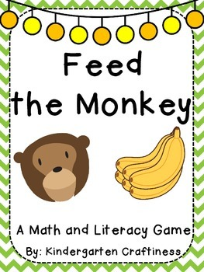
Tuesday Activity: Planting a seed

Tues 24th | Jaspers Beanstalk: Plant a seed  Listen to the Jasper’s Beanstalk story by following the link https://www.youtube.com/watch?v=jemrWJX7xJo  What did Jasper do in the story?  How did he take care of his plant?  Why doesn’t his plant grow?  What did Jasper do at the end of the story?  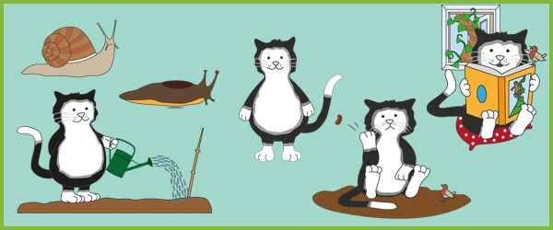  Today, we will plant a seed to see how our plant will grow. You will need a seed, pot, soil or cotton wool, water and sun!  Follow the teacher to see what she does with her seed!  Can you send a picture of your seed or if you cannot plant one, something you take care of and help grow in your house! | D3 Tall and short  Today we will order our beanstalks from shortest to tallest.  Can you find the tall beanstalk saying, this beanstalk is tall and the short beanstalk, saying this beanstalk is short.  Can you order them starting with the shortest.  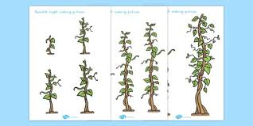  Can you send me a quick clip of how you did this?
Wednesday activity: Rainbow hunt

Wed 25th | Rainbow hunt  Watch this video of a plant growing.  https://www.youtube.com/watch?v=w77zPAtVTuI  What does it need? What is happening to the plant? What do you think will happen next to your seed?  What does your seed need today?  Can you sequence the pictures and send them to your teacher on your Portfolio?  Activity:  We are going to go on a rainbow hunt in your house.  What colours can you see in the rainbow? Where are they around your house?  Can you gather all the colours faster than your sibling?  Send us a video of what you found on your hunt. “I got a.....”. | D4 Counting out to match a number.  Can you count to the fruit to match the number of the very hungry caterpillar. We must count aloud and stop when we get to the number. Practise 1-5 and then higher as a challenge.  Challenge – Can you check your work is correct by counting with your counting finger after?
Thursday Activity: Making sandwiches

Thurs  26th | Titch story-link to story  https://www.youtube.com/watch?v=Lm8Pg5iwJL4  Listen to the story.  Who is in the story?  Where does the story take place?  What are the children doing?  Are they all the same or different?  Are their instruments the same?  Are their tools the same?  How are they different?  Can you use the language of little, big and bigger to describe them?  Can you send a picture of how your plant is doing today? | D5 Using the language of size, little, big, bigger...  https://www.youtube.com/watch?v=Lm8Pg5iwJL4  You have read and watched the story of Titch. Titch was very busy with his big sister, Mary (use big gesture) and his bigger brother, Pete. They are feeling hungry. I have lots of food to give Titch and his big sister and bigger brother.  Today we will make sandwiches for Titch and his siblings.  Can you tell me about the sandwiches you made?  Some key language I want to hear will be:  Little, big and bigger.  Can you cut out and order the characters from the story?  Looking forward to hearing your news!

